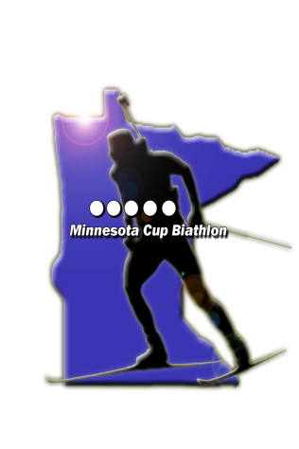



**Minnesota Cup: Biathlon Race & Novice Race**

***Hosted by Mt.Itasca Nordic Ski Association***

Date: **Saturday, March 11. 2017**

Place: **Mt.Itasca, Coleraine**

Race Format: **Mass Start (PPSS)**

Distance**: G, YW, JW, SW, MW: 7.5km**

**B, YM, JM, SM, MM: 10km;**

Registration: **9:30 AM – 10:00 AM**

Zero: **10:00 AM – 10:30 AM**

Race Start: **10:45 AM Mass Start**

Cost:  **$20 (cash or check payable to MINSA)**

**Novice Race (recommended age: 13+)**

**~ Registration: 9:30 – 11:30am**

**~ No previous shooting experience necessary!**

**~ Instruction, Rifles, and Ammo provided.**

**~ Novice Race will follow the main race.**

**~ Safety Clinic prior to the Race**

**~ Start approx. at 12-12:15PM**

**~ Race Format: Mass Start – 4.5k (3x1.5k), PP + penalty loop**

**~ Cost: $20 (cash or check payable to MINSA)**

**Awards for Biathlon & Novice Race**: after completion of both races.

Questions? Call **Vlad** or **Petra 218-999-5046**  or e-mail[**pcervenkova@hotmail.com**](mailto:pcervenkova@hotmail.com)



**Competitor Entry Form**

Last Name: ____________________________ First Name: _______________________ Sex: M / F

Address: _____________________________ City:__________________ State: ___ Zip_________

Email: ______________________Phone:_______________ Birth date: ___/___/___ Age:_______

***Class/Age:*** □ EXPERIENCED Biathlete □ NOVICE

□ Master men □ Masters women Air Rifle □ 5 - 7 years old

□ Senior men □ Senior women □ 8 - 10 years old

□ Junior men: 19-20 years □ Junior women: 19-20 years     □ 11 - 13 years old

□ Youth men: 17-18 years □ Youth women: 17-18 years

□ Boys: 15-16 years □ Girls: 15-16 years Candy Cup □

***Entry Fees: $ Checks payable to Mt.Itasca Nordic Ski Association.***

**WAIVER AND RELEASE OF LIABILITY**

**Identification of risk**. I, ___________________________, know that biathlon, consisting of Nordic skiing and rifle marksmanship, involves risks of serious injury, including permanent disability and death. I understand that these injuries might result not only form my actions, but the actions, inactions, or negligence of others.

**Assumption of risk**. I agree that I am responsible for my safety while participating in biathlon training and competition. I assume all risks, both known and unknown, connected with my participation.

**Waiver.** Being aware of the risks and willing to assume them, I waive, release and hold harmless City of Coleraine, Minnesota Biathlon, Biathlon Community Development Programs, Minnesota Shooting Sports Education Center, United States Biathlon Association, Mount Itasca Ski and Outing, Mount Itasca Nordic Ski Association and its directors, officers, employees, coaches, volunteers, sponsors, advertisers, and owners/lessors of used premises from all claims for liability, injury, loss, or damage connected with my participation in biathlon training and competition. I intend for this waiver and release to also apply to my relatives, personal representatives, heirs, beneficiaries, next of kin, and assigns.

**Insurance.** I currently have, and agree to maintain through the time I participate, sufficient medical and accident insurance. I understand that this is my responsibility and release anyone from providing it for me.

I have read this agreement carefully, understand that I give up substantial rights by signing it, and sign it voluntarily.

_____________________________________ Date ____________________

**Participant’s signature**

**For Participants under age 18:**

I consent to the above person’s participation in biathlon training and competitions. I acknowledge that I assume all risks, known and unknown, and waive all claims in advance.

_____________________________________ Date _____________________

**Parent/guardian’s signature**